Basic assignment 2

a) Create Triangular, Trapezoidal, Gaussian, and Sigmoidal membership functions.
Answer:
b) Implement α-cuts and strong α-cuts of fuzzy sets.
Answer: This
c) Perform basic operations (Union, Intersection, Complement) on fuzzy sets.
Answer:

Problem Sheet 1
Problem Statement: Employee satisfaction is described as Low, Moderate, and High. Model satisfaction levels using Gaussian and triangular membership functions. Apply α-cuts to identify acceptable satisfaction intervals. Use strong α-cuts to detect highly satisfied employees. Perform fuzzy union and intersection to analyze overlapping satisfaction categories.
Mathematical Modeling: Let's define the universe of discourse $X=[0,10]$ representing satisfaction scores.
For triangular function T(a,b,c)
$$μ_{T}\left(x\right)=\left\{\begin{matrix}0 & x≤a \\ \frac{x-a}{b-a} & a<x≤b \\ \begin{matrix}\frac{c-x}{c-b} \\ 0\end{matrix} & \begin{matrix}b<x≤c \\ x≥c\end{matrix}\end{matrix}\right\}$$
Low satisfaction $L_{T}:T(0,0,4)$
$${μL}_{T}\left(x\right)=max\left(0,min\left(1,\frac{4-x}{4}\right)\right)$$
Moderate Satisfaction $M_{T}:T(2,5,8)$
$${μM}_{T}\left(x\right)=\left\{\begin{matrix}0 & x≤2 \\ \frac{x-2}{3} & 2<x≤5 \\ \begin{matrix}\frac{8-x}{3} \\ 0\end{matrix} & \begin{matrix}5<x≤8 \\ x≥8\end{matrix}\end{matrix}\right\}$$
High Satisfaction $H_{T}:T(6,10,10)$
$${μH}_{T}\left(x\right)=\left\{\begin{matrix}0 & x≤6 \\ \frac{x-6}{4} & 6<x≤10\end{matrix}\right\}$$
For Gaussian membership function $G(m,σ)$

$$μ_{G}\left(x\right)=e^{-\frac{(x-m)}{2σ^{2}}}$$
Low satisfaction $L_{G}:G(0,1.5)$
$${μL}_{G}\left(x\right)=e^{-\frac{x^{2}}{4.5}}$$
Moderate Satisfaction $M_{G}:G(5,1.5)$
$${μM}_{G}\left(x\right)=e^{-\frac{(x-5)}{4.5}}$$

High Satisfaction $H_{G}:T(10,1.5)$
$${μM}_{G}\left(x\right)=e^{-\frac{(x-10)}{4.5}}$$
For $α$-cut:
$$A_{∝}=\left\{x∈X|μ_{A}(x)≥α\right\}$$
Let’s use $α=0.5$ and $α=0.7$
Now with Alpha cut the triangular function become:
Lower Satisfaction
$$μ\left(x\right)=\frac{(4-x)}{4}≥α$$
$$x≤4(1-α)$$
Moderate Satisfaction
$$\frac{(x-2)}{3}≥α and \frac{(8-x)}{3}≥α$$
$$2+3α≤x≤8-3α$$
High Satisfaction
$$\frac{(x-6)}{4}≥α$$
$$x≥6+4α$$
Now with Alpha cut the Gaussian functions become:
Lower Satisfaction
$$e^{(-\frac{x^{2}}{4.5})}≥α$$
$$x≤-4.5 ln(α)$$
Moderate Satisfaction
$$e^{-\left(\frac{{\left(x-5\right)}^{2}}{4.5}\right)}≥α$$
$$|x-5|≤\sqrt{-4.5ln⁡(α)}$$
High Satisfaction
$$e^{-\left(\frac{{\left(x-10\right)}^{2}}{4.5}\right)}≥α$$
$$|x-10|≤\sqrt{-4.5ln⁡(α)}$$

Strong α-Cuts for Highly Satisfied Employees
Strong $α$-cut: $A_{α+}=\left\{x∈\left.X\right|μ_{A}(x)>α\right\}$
Union and Intersection
$$μ_{A∪B​}\left(x\right)=\max\left(μ_{A}​\left(x\right),μ_{B}​\left(x\right)\right)$$
$$μ_{A∩B​}\left(x\right)=\min\left(μ_{A}​\left(x\right),μ_{B}​\left(x\right)\right)$$
Implementation:

Algorithm:
Input: Employee satisfaction scores S = {s₁, s₂, ..., sₙ} where sᵢ ∈ [0,10]
Output: Membership values, α-cuts, fuzzy operations results

BEGIN
1. DATA INITIALIZATION
Create employee dataset with satisfaction scores covering [0,10]
Assign departments randomly.
2. MEMBERSHIP FUNCTION DEFINITION
2.1 Triangular Functions:
- Low: μ_L(x) = max(0, (4-x)/4) for x≤4, else 0
- Moderate: μ_M(x) = piecewise:
* 0 for x≤2
* (x-2)/3 for 2<x≤5
* (8-x)/3 for 5<x≤8
* 0 for x>8
- High: μ_H(x) = 0 for x≤6, (x-6)/4 for 6<x≤10

2.2 Gaussian Functions:
- Low: μ_L(x) = exp(-x²/4.5)
- Moderate: μ_M(x) = exp(-(x-5)²/4.5)
- High: μ_H(x) = exp(-(x-10)²/4.5)
3. MEMBERSHIP CALCULATION
FOR each employee i:
Calculate all six membership values
Store in membership matrix M[i][j]
4. α-CUT ANALYSIS
FOR α in {0.3, 0.5, 0.7}:
Calculate triangular α-cuts:
Low: [0, 4(1-α)]
Moderate: [2+3α, 8-3α] if valid
High: [6+4α, 10]

Calculate Gaussian α-cuts:
bound = √ (-4.5 ln α)
Low: [0, bound]
Moderate: [5-bound, 5+bound]
High: [10-bound, 10]

5. STRONG α-CUTS
Find employees with μ_H > 0.8
Report as "Highly Satisfied"

6. FUZZY OPERATIONS
FOR each employee:
Union(A,B) = max(μ_A, μ_B)
Intersection(A,B) = min(μ_A, μ_B)
Complement(A) = 1 - μ_A

7. SET PROPERTIES
Calculate for each fuzzy set:
Cardinality = Σ μ(x)
Support = {x | μ(x) > 0}
Height = max(μ(x))
Core = {x | μ(x) = 1}

8. VISUALIZATION
Plot membership functions with data points
Create heatmap of membership values
Show α-cut regions
END

Code:
Output:
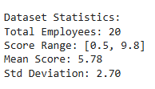
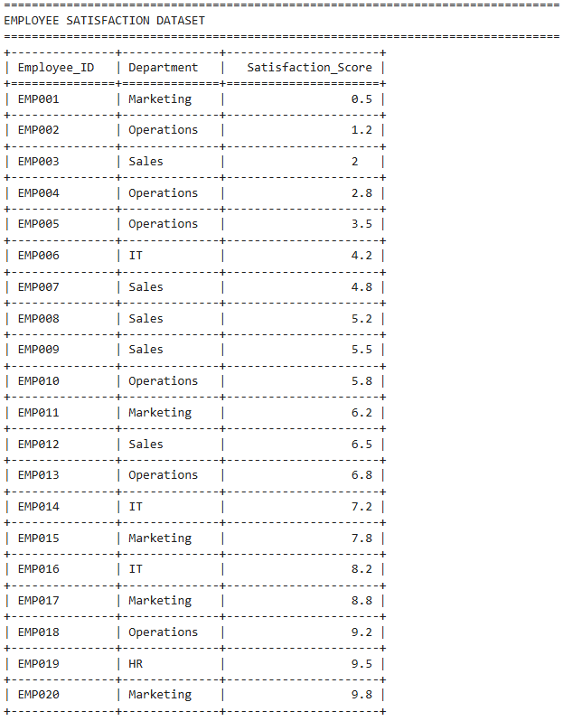
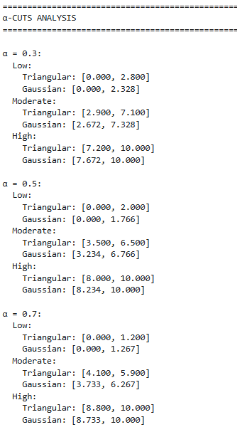
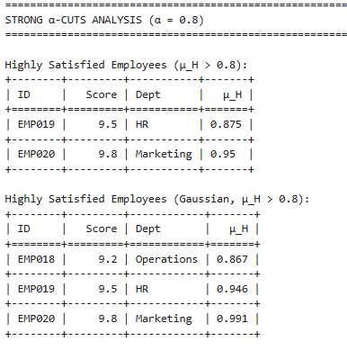
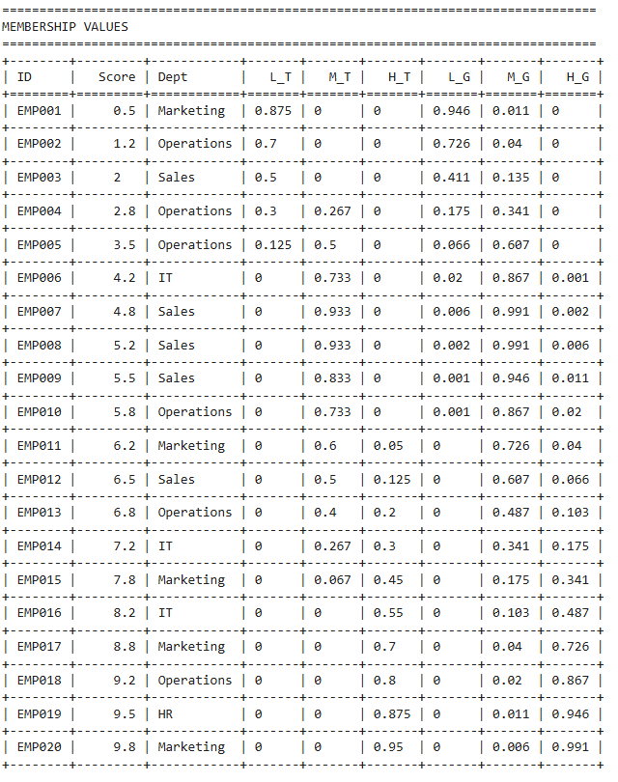
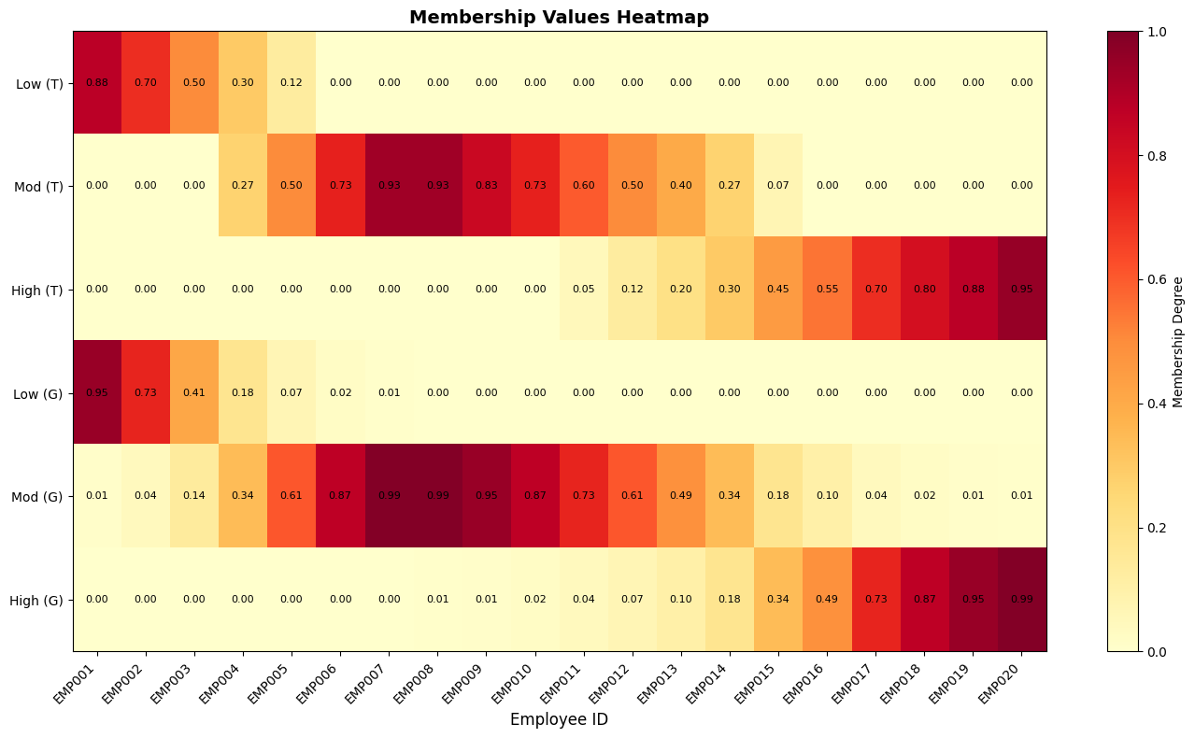
Fig 1. Visualization of membership value through heatmap.
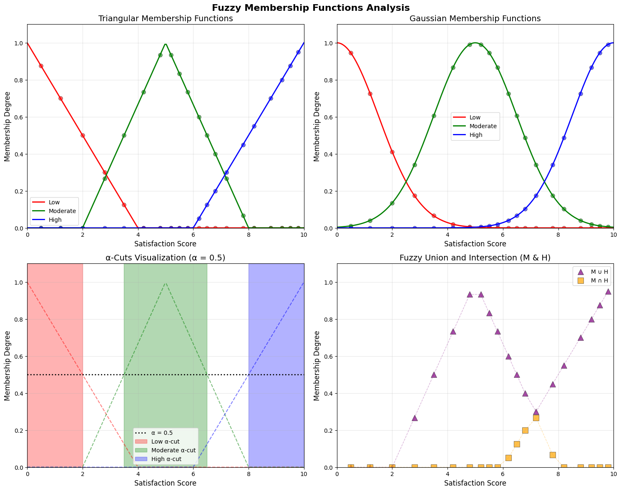
Fig 2. Visualization of the membership functions, influence of alpha value 0.5 in trapezoidal rule and union, intersection to analyze overlapping satisfaction categories.
Interpretation:
From the fig 1. a comprehensive view of all membership values across employees, where darker red cells indicate stronger belonging to a category, clearly showing EMP001-003 as Low, EMP005-012 as Moderate, and EMP016-020 as High satisfaction. Fig 2. Shows distinct satisfaction categories with sharp boundaries, where employees with scores 0-4 belong to Low, 2-8 to Moderate, and 6-10 to High, with clear transition points at 4 and 6.
Gaussian Membership Functions Plot: Displays smooth, overlapping satisfaction curves where employees can belong to multiple categories simultaneously, particularly in the 4-6 score range where Moderate peaks while Low and High have gradual transitions.
α-Cuts Visualization: Highlights satisfaction intervals at α=0.5 threshold, revealing that employees with scores 0-2 are definitively Low, 3.5-6.5 are Moderate, and 8-10 are High satisfaction.
Union and Intersection Plot: Shows combined Moderate-High satisfaction regions (union) peaks at 7.5, while their overlap (intersection) maximizes at 7.0, indicating the transition zone between satisfaction levels.
Conclusion:
The fuzzy system provides management with a nuanced understanding of satisfaction levels through membership degrees rather than rigid categories. By identifying employees in ambiguous regions (scores 4-6 where satisfaction overlaps), management can target interventions precisely. Strong α-cuts (>0.8) reveal truly satisfied employees, while low satisfaction intervals highlight areas needing improvement, enabling data-driven workplace enhancements.

